1) A) Description of Site:
- Location: Starbucks
- Date sample D got collected: 10-18-2019
- It’s Starbucks, gives coffee and pastries to customers, and this one happens to have had a fairly perfect drive-through to investigate. I gathered data almost right at 7:00 in the morning, and took about 2 hours, it couldn’t have been better!
B) Picture of the line of site:
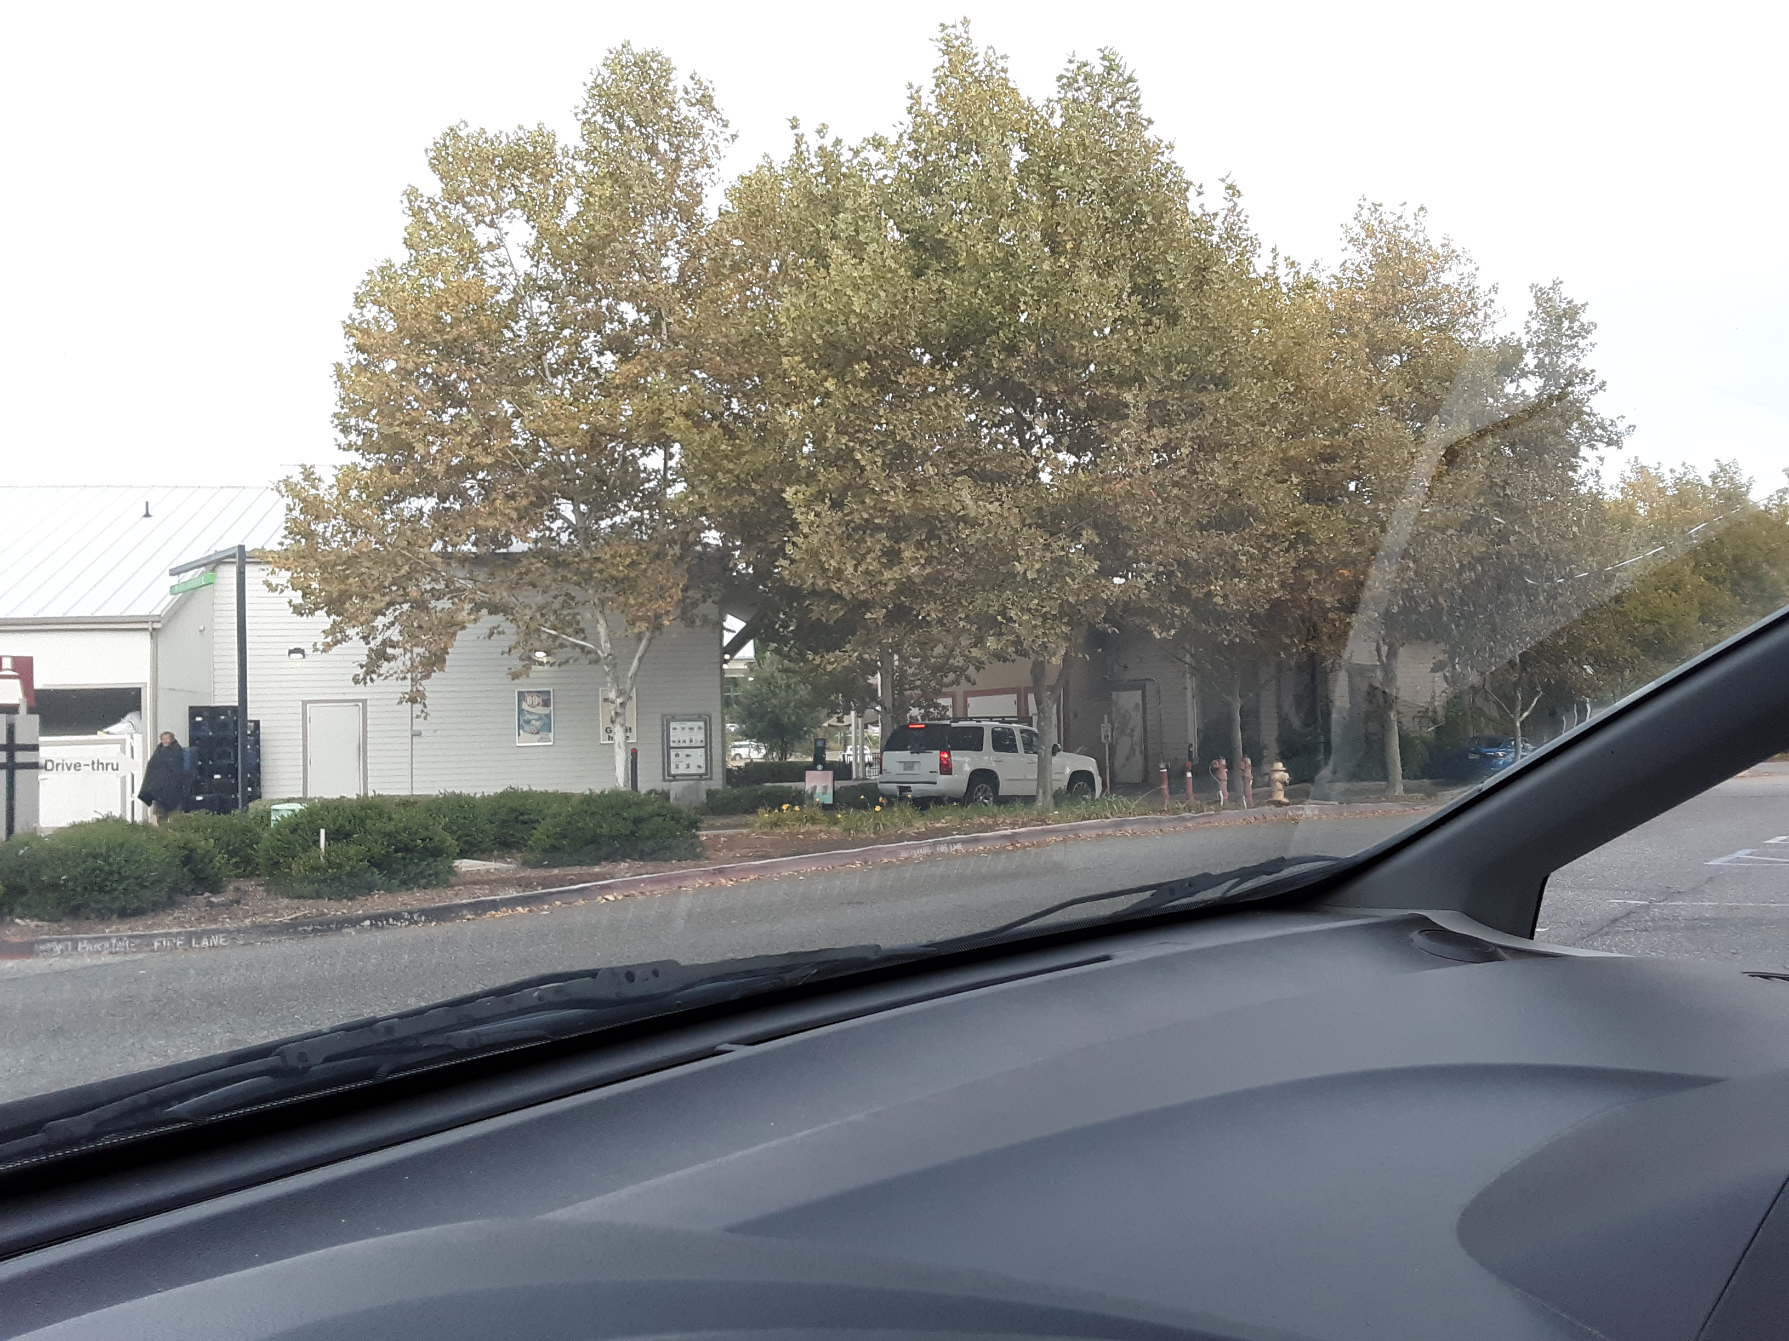
Customers would wrap around that curve, so it made keeping track of new Cj’s straightforward. The white vehicle is at the Order box, blue vehicle (harder to see) is at window.
C) nSteps: As per above, O+(P&G), nSteps would equal 2.

2) Spreadsheet: ( 1 to 50 here, 51 to 100 on next page )

3) A) 1. Sub Interval Sizes (SIS) = 5 minutes each. T = 2 hours or 120 minutes, so 24 SIS in total.
2. x^ = (total number of Cj arrivals / number of SIS) = (100/24*5) = 100/120 which is approximately 0.834
B) Histogram of frequency distribution of Cj arrivals.
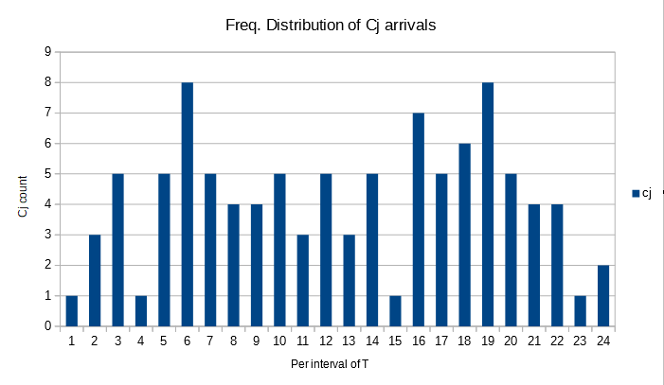

C) Histogram of service durations; each service duration is time between 0 and 1 minute, 1 minute and 2 minutes, etc.
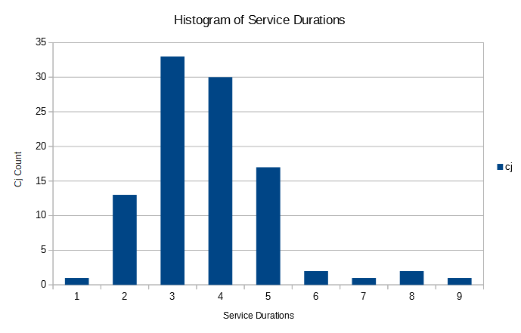
4) A) λ^ = ( number of Cj that arrived ) / ( observation duration ) = 100 / 120 = 0.834 Cj/minute
W^ = ( Total time spent in S by all Cj ) / ( total cj ) = 498.6 minutes / 100 Cj = 4.986 minutes/Cj avg.
( Total time in seconds = 29,916, divided by 60 it equals 498.6 minutes )
L^ = ( sum* of value L as each Cj arrives ) / ( total number of c ) = 417 / 100 = 4.17
* Your slides (P2, Slide 20) claim to find the average, but seems more like a sum to me...
Does this hold up?
λ^ * W^ = 4.986 * 0.834 = 4.158 … Yes, I would say Little’s Law does!

B) Calculate the ratio!

Ratio = L^ / ( λ^ * W^) = 4.170 / 4.158 which is about 1.003

